Part 1 - Iperfer on Wired Environment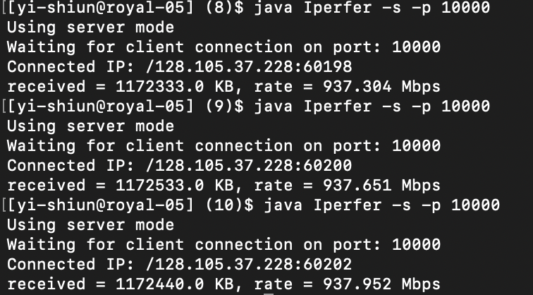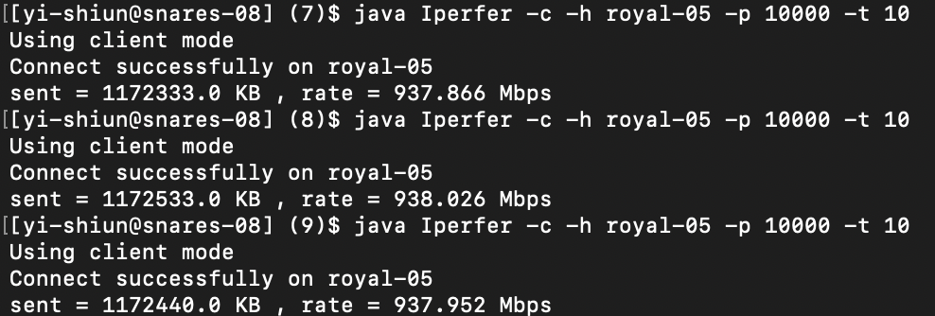

Part 1 - Wireless Environment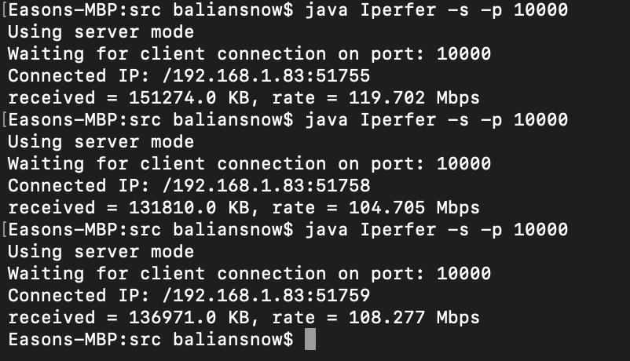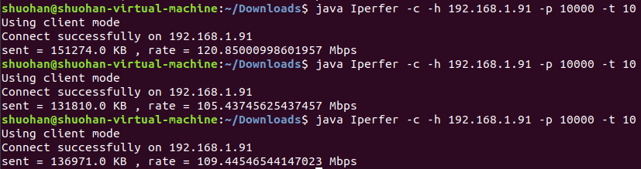

We expect wired environment would generate greater throughput than that in wireless environment. Given the amount of data sent to server is subject to client running environment instead of network, total latency would be the main reason that has impact on throughput. Consider the three factors of latency:

Propagation Delay: we test wired/wireless environment both in the same network, so propagation delays are supposed to be minor.

Transmission Delay: transmission delay will be the factor that differentiates wired and wireless network. Wired network, especially fiber, will usually provide a larger bandwidth in comparison with wireless networks and thus generate a smaller delay(N/C).

Queuing: in wired environment, we are sending data via direct connection and without traffic, so no queuing issue here. In wireless environment, data could be queued in a switch / router between our two machines.

Path Latency and Throughput

For Throughput:

We predict that Q2 Mbps should be similar to the Mbps of L1, because the Mbps of L1 is the lowest Mbps among L1, L2, and L3. Our prediction is correct. (L1 = throughput_L1.txt)

We predict that the received data of the Q2 server should be similar to the received data of the L1 server, but the result of the Q2 server is much lesser than each received data of the L1, L2, and L3 servers. We believe this situation could be caused by the environment of the CS machine, because it has only one CPU.

For Latency:

The average RTT of Q2 should be the sum of the average RTTs of L1, L2, and L3, and our prediction is correct. We do not predict min/max/mdev RTT because we think they are unpredictable based on the information of L1, L2, and L3, however, min RTT of Q2 is also the sum of min RTTs of L1, L2, and L3, and this min RTT situation could happen before L1 has a traffic jam, we mention L1 because L1 is the bottle neck of L1, L2, and L3.

Propagation Delay: the distance is longer, so Q2 has more propagation delay.

Transmission Delay: L1 is bottleneck and it constrains the transmission.

Queuing: data could be queued on s1, because L1 is bottleneck.

Effects of Multiplexing

Two Paris:

H7-H9

Received 17548.0 kb, Rate 3.554295262 Mbps

Time 30976 ms, RTT min/avg/max/mdev = 140.065/291.068/521.595/131.103 ms

H1-H4

Received 16311.0 kb, Rate 3.9365270906 Mbps

Time 31403 ms, RTT min/avg/max/mdev = 140.096/295.945/523.041/135.218 ms

We assume that the total received data should be similar to the received data of Q2, and it is correct, there is only one CPU in CS machine should be the reason.

The Mbps of each pair should be half Mbps of Q2, because two pairs are sharing the same series of links.

We believe Time should be twice as big as Time of Q2, but Time is almost the same as Q2, and our wrong prediction is resulted from that we forget the total sending data is the same as Q2 because of one CPU.

We predict that average RTT should be similar to what we have discovered in Q2, but it is a little higher, we believe this situation is resulted from Queuing.

Propagation Delay: the distance is the same as Q2, so propagation delay is the same.

Transmission Delay: Transmission delay is the same while comparing two pairs of hosts with Q2, it is because that the sending data of each pairs is half as sending data of Q2, and the capacity of links are shared by two pairs. N/C = (N / 2) / (C / 2)

Queuing: data could be queued on s1, s2, and s2, because we have two pairs of hosts on the same links.

Three Pairs:

H1-H4

Received 13820 kb, Rate 2.80901445 Mbps

Time 30689ms, RTT min/avg/max/mdev = 140.057/255.985/622.924/148.979 ms

H7-H9

Received 5776 kb, Rate 1.3225714122 Mbps

Time 30200 ms, RTT min/avg/max/mdev = 140.049/285.139/818.339/181.344 ms

H8-H10

Received 15950 kb, Rate 3.59608827 Mbps

Time 30590 ms, RTT min/avg/max/mdev = 140.055/255.995/622.895/149.123 ms

Our predictions are correct for three pairs except that we assume that three pairs of hosts should share with each others equally. The H7-H9 pair is sending/receiving a much lower data, but our conclusion is the same as two pairs.

Effects of Latency

For throughput:

The sending/receiving data is not decreasing for H1-H4 pair when H5-H6 pair is also running. The throughput for H1-H4 should be similar with Q2, it is because that the throughput H1-H4 is limited by L1, and the throughput of H5-H6 is limited by L4 or L5, and the capacity of L2 is above the sum of L1 and L4, or above the sum of L1 and L5.

For latency:

Propagation Delay: the two pairs have different distance, so have different propagation delay.

Transmission Delay: H1-H4 transmission delay should be similar to Q2 transmission delay. Surprisingly, the max RTT of H1-H4 is higher than the max RTT of Q2 in our example, this situation tells that L1 as a bottleneck plays an important role.

Queuing: data should not be queued on s2, because L1 and L4 are bottlenecks for H1-H4 and H5-H6.